WEST WILTS FLYFISHERS GUILD



Members of the Wild Trout Trust

APRIL 2010 Newsletter

Website: http://wwffg.tripod.com/

William Arney’s talk on Bee-Keeping (Honey Bees)

Bewitching, bee-utifully presented, be-decked with exemplary physical exhibits of the craft, and bee-yond adequate praise. William gave us a night to remember and his presentation was a joy. If I could half-remember Henry V’s famous rousing oratory to his troops when assembled before the Battle of Agincourt (and mercifully I can’t) I would paraphrase thus, that all good men of England would rue the day, bee veritably missing out if you like, had they the misfortune not to bee there. So it was with William’s talk on bees and honey-making.
We sometimes forget what a wealth of characters and combined knowledge we have (except at the Christmas and Ladies Night quizzes!) within the Guild membership. William is extremely knowledgeable, and this showed in his presentation. From bees-wax to honeycombs; from the ash tree smoking paraphernalia, to how to deal with bee-stings. A healthy reminder on that note of where not to stand when harvesting the honey. Never, never, never, under any circumstances, stand in front of the hive entrance! Not as you may think, to steer clear of angry and vengeful sentry bees coming out of the hive, but to avoid the venom of returning bees, on warp speed seventy, heavily laden with nectar who just can’t stand any ass getting in their way when docking. Literally. That derriere is in for a rude and painful shock!

Thank you again William for the talk. It was an education and truly fascinating in its detail. Also enjoyed of course, was the chance to buy some of the delicious honey produce at the end of the evening. Please contact William directly if members wish to try this for themselves.

Next meeting - Sea Trout at the Bottom of the World
At our next meeting on 12 May, we are in for another treat when Jon Jonik has kindly agreed to give us an account of his recent journey to South America in pursuit of the mighty sea trout there.
Miss this at your peril !
If this writing were in Technicolor, I would be penning this in green ink. Excuse me now, I’m just off to rattle the bird-cage….. Courteney

BOBS BITS………

Members will be interested to read this ‘Thank You’ letter from the RNLI-

Mr Jim Olds,
8 Lower Meadow,
Ilminster,
TA19 9DP.
24.03.2010.

Dear Mr Harris,
On behalf of the RNLI a very big thank you.

When Carole rang to tell me that you had arranged to do an auction of the Late John Lewis’ books, I never imagined you would raise the wonderful amount of £327.50.

Please thank your Guild Members for being so generous, it was a wonderful thing to do in memory of a wonderful, larger than life man, as was John, and for Carole to give the money to the RNLI.

This money will go a very long way to help keep these very brave people who volunteer to go to sea to save others. So once again to you all THANK YOU.

Yours sincerely,

JG Olds.
o0o0o0o0o0

THE CHEW BOAT CUP
This competition is being held on Sunday 16th May, where we shall be fishing for the Chew Boat Cup and also for a bottle of wine awarded for the heaviest single trout (pike don’t count!)
The following Members have registered to fish: Bryan Hussey, Chris Holt, Maurice Dyer, Rob Eadie, Colin Burbedge, William Arney. Tim Pullen, Andy Greatwood, Jon Jonik, Stan Jonik, Gerry Barnes, Chris Peasden and Jim Wheel. To save cancelling a boat we need one more person to fish. Can you volunteer?
Please give Robert a ring on 01225 864739 or E-Mail: Robert.is@trouthooker.net

If you haven’t paid for your fishing (£32:50) then please pay Colin on the day.
It is almost tradition now that we meet for breakfast (£5.50) at Woodford Lodge before a great days fishing.
A quick briefing at 9:45am on the lawn. As we did last year, we shall pick names ‘out of a hat’ to find our partners for the day, and boat numbers will be distributed. Please remember to wear a safety harness supplied free by Bristol Water. Check your boat has a net, an anchor and bailing bucket - just in case!

Fishing starts at 10:00am to weighing in at 6:30pm. Buzzers, Diawl Bachs and PT Nymphs should find the fish. If the trout are feeding on the surface do not hesitate to tie on a team of dries, perhaps the Bobs Bits, Hoppers or Raiders picked out, should do the trick.
Whether we catch loads of fish (limited to 8 trout) or not, it’s good to have a day out on the reservoir, discussing tactics and putting the world to rights!
Let’s keep our fingers crossed that we will have a cloudy humid day with a gentle breeze. Look forward to seeing you there.
Finally, please abide by the rules of the Bristol Water Fishery.
~~~~~~~~~~~~~~~~~~~~~
Message from Member Derrick Jones……
Should any Club Members be interested, I am
running a number of beginner / improver courses down in Devon this year.
The first are in May, stillwater courses at Kennick on the 1st of May, a
lovely lake in mid Devon and the second on the 22nd at Wistlandpound - a
40 acre lake about 25mins from South Molton. The number of places is
limited to 10 per course with two AAPGAI instructors - Mark Bailey and
myself. We aim to cover the basics of tackle, casting, entomology and
tactics on medium - large stillwaters. The cost is £25 per person for a
6 hour course and allows you to take a fish should you catch one, which
I think is very good value. Should they prove popular we will run
similar courses later in the year.
We are also planning to run saltwater flyfishing and pike flyfishing introductory courses this year.
Further information at www.adventureflyfishinguk.co.uk
or email derrick.flyfishing@googlemail.com or call 07974 263990

<o((((>< Fishtails…
If “stream” meant flowing water, “river” originally meant something with banks. It derives from the ancient root rei - meaning to cut or tear. From it comes the Latin riparia meaning “shore” from which we get “riviera” as well as “rift”, “riven, “rip” and “rifle”, (as in “rifling through drawers”).
This dividing function means rivers were often used as political boundaries. The Mersey is so called because it was once the northern boundary of Mercia, dividing it from Northumbria (the land north of the river Humber).
The technical name for a river’s deepest continuous point is its thalweg, an English word composed of two German elements (Thal meaning “valley” and Weg, for way).

- In English pubs, ale is ordered by pints and quarts... So in old
England, when customers got unruly, the bartender would yell
"Mind your pints and quarts, and settle down."
It's where we get the phrase "mind your P's and Q's"

- A Rhyme to take note of….
Embarrassing to admit, in the past I’ve been so excited and hasty about going off in the car for a day’s fishing, that half way down the road I’ve looked back in the rear view mirror to see NO rod!
Here is a rhyme which should rectify this problem……
Rod, reel,
Flask, creel,
Net, fly book
And lunch!

- Birds that heralds the Spring
Good to hear from Maurice Dyer that on the third week of March, while fishing on Chew he saw a huge flock of House Martins estimated at 300 birds feeding on those notorious black buzzers that hatch from the lake at this time of year.
On his visit he also saw a rare Cetti’s Warbler in the high reeds over at Wick Green. A small shy bird just over 5’’ long, looks similar to a nightingale but has a loud abrupt and repetitive song.
At time of writing, have seen some Swallows at Mill Farm but no Swifts as yet.
Wonder if we shall hear the Cuckoo this year?

RODS for SALE….
Tim Pullen has three second-hand rods for sale. All the rods are in great condition…..

ORVIS T3, 9ft weight 6 a mid-flex four piece in a smart tube…..£100. ONO.

ORVIS TRIDENT TLS. 7’ 11’’ weight 4, mid-flex. 2 piece in a smart tube….£100. ono

DAIWA WHISKER FLY 9’6’’ weight 6-7. 2 piece in a tube………….£50.

These are nice rods so please give Tim a ring on 078097 58167.
If interested Tim could bring a rod(s) to the May Meeting to show you!

The Olive Upright (Rhithrogena semicolorata)

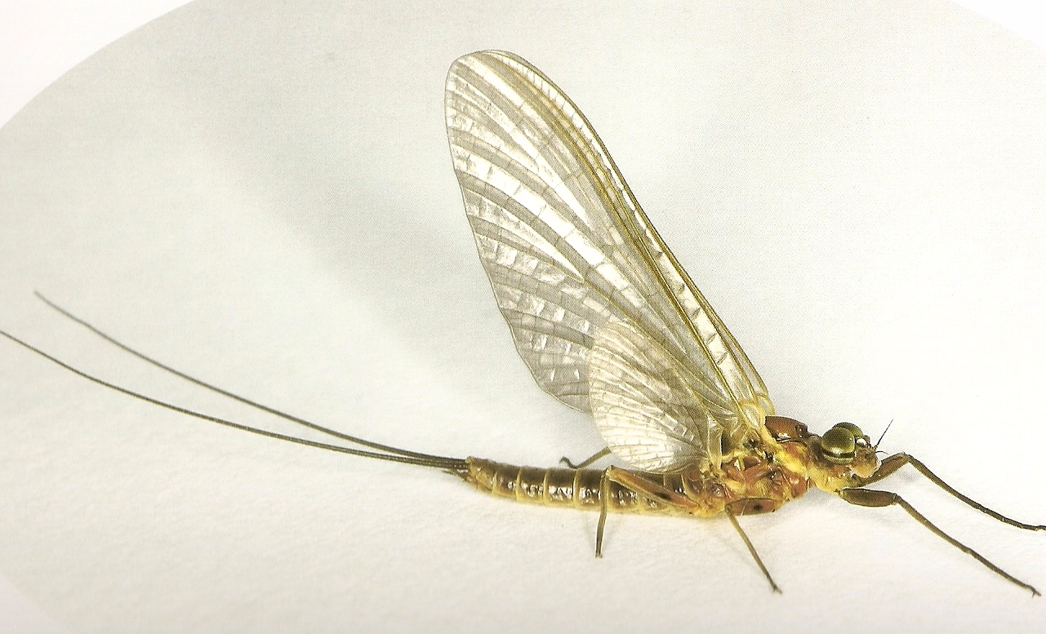

The Olive Upright is a common and abundant mayfly of swift running waters. Nymphs can be found in the riffle areas of rivers and streams where they are usually found clinging to submerged plants and stones, although they may swim if disturbed.
Emergence of adults typically takes place at the surface of the water at anytime between dawn and dusk. Males of this species can be found swarming throughout the day. Once mated, the female flies upstream and releases a few eggs by dipping the tip of her abdomen into the water at intervals whilst in flight, or by settling on the water surface for short periods.

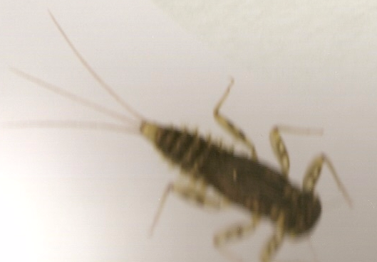

There is one generation per year that overwinters as nymphs. As growth rates vary with water temperature, the periods over which adults emerge is variable, but adults have been found between April and September in the British Isles.

Sunday April 11th A Report on the Sutton Bingham Spinnaker Cup Competition

A nippy north-easterly wind made fishing very difficult for some on the popular South Bank of this 123 acre lake. Tim and I had to punch the line out to find the fish. But plenty of stockies about patrolling the shoreline. It didn’t take us long to catch our five well earned rainbow trout.

Seven Members attended the Competition who quite sensibly fished the north bank. Everyone caught fish ranging from one and a half pounds to Chris Peasden’s excellent three and a half pound Rainbow.
A variety of flies found fish including Black Buzzer, Red head Diawl Bachs, Pearly Cormorant and the reliable (couldn’t do without) Damsel Nymph.
The hazy sun tried to come out but it remained a draughty day. No sign of any migrants (birds)
on the lake. One point to mention is that a concessionary ticket for Sixty and over is only £15 for 5 fish – really good value.
I think everyone enjoyed the day out at Sutton Bingham.
There isn’t another lake quite like this one.
The winner of the Spinnaker Cup is…..
1st Maurice Dyer……5 fish…….12lbs.2ozs. Congratulations.

2nd Chris Peasden….5 fish…….11lbs.08ozs.
3rd Robert Eadie……5 fish…….10lbs.
An absolutely excellent bottle of fishing plonk was captured by Chris for his three and a
half pounder rainbow.
Thanks to all who attended the club match. Our next outing will be the Chew Boat Cup on May 16th.

BUGS AND GRUBS SEMINAR

The proposed dates for 2010 are 26 and 27 June, and 3 and 4 July.
Please give your first and second choices of date as we will be limiting the classes to twenty students. There are still a few places left on each of the days. Identification courses to be held at Langford Lakes and the adjacent River Wylye (near Salisbury).
The basic agenda for the one–day courses is:
9–00 am Meet for coffee
9–30am Welcome by Richard Cripps for the Wiltshire Wildlife Trust and Shaun Leonard for the Wild Trout Trust.
9–45am Introduction to the factors that affect life in rivers and lakes, recognition of harmful and beneficial influences, means of collecting specimens, methods of identification.
10–45 am Fieldwork on the nearby river Wylye (bring your own
waders or gum boots).
12–45 pm Lunch (bring your own picnic; coffee and tea provided).
2–00pm Fieldwork on the nearby Langford Lakes.
4–00pm Closing discussions (all times will be flexible).
The cost of a one–day course is £25. Applications, accompanied by full payment, should be sent to Christina Bryant, The Wild Trout Trust, PO Box 120, Waterlooville, PO8 OWZ. Telephone/fax 023 9257 0985, email:office@wildtrout.org.

SKITTLES AT HART
"A great time was had by all 18 members and spouses who attended the Skittles Evening at the White Hart in Atworth on Friday 26th March.
Congratulations and a bottle of wine went to Pat Hussey, who was the star of the evening as the 'top lady' and also top score overall for the night.
Congrats and a bottle of plonk also went to Gerry Tinson. Finishing only one point behind Pat, Gerry just overtook JJ in the last round, to win 'top chap' by a single point." Malcolm

HAPPY FISHING…..BOB.
PS.
Murphy staggered home very late after another evening with his drinking buddy, Paddy. He took off his shoes to avoid waking his wife, Kathleen.
He tiptoed as quietly as he could toward the stairs leading to their upstairs bedroom, but misjudged the bottom step. As he caught himself by grabbing the banister, his body swung around and he landed heavily on his rump. A whiskey bottle in each back pocket broke and made the landing especially painful.
Managing not to yell, Murphy sprung up, pulled down his pants, and looked in the hall mirror to see that his buttocks were cut and bleeding.
He managed to quietly find a full box of plasters and began putting a plaster as best he could on each place he saw blood.
He then hid the now almost empty plasters box and shuffled and stumbled his way to bed.
In the morning, Murphy woke up with searing pain in both his head and bottom and Kathleen staring at him from across the room.
She said, 'You were drunk again last night weren't you?'
Murphy said, 'Why you say such a mean thing?'
'Well,' Kathleen said, 'it could be the open front door, it could be the broken glass at the bottom of the stairs, it could be the drops of blood trailing through the house, it could be your bloodshot eyes, but mostly ....... it's all those plasters stuck on the hall mirror.

PPS.
☺ Is it too early to tell jokes about volcanoes? Better let the dust settle first!

